GUEST OF THE MONTH
November 2025

BILL HASENCAMP
METROPOLITAN WATER DISTRICT OF SOUTHERN CALIFORNIA (MWD)
UPDATE ON COLORADO RIVER NEGOTIATIONS

Summary by Robert Yoshimura
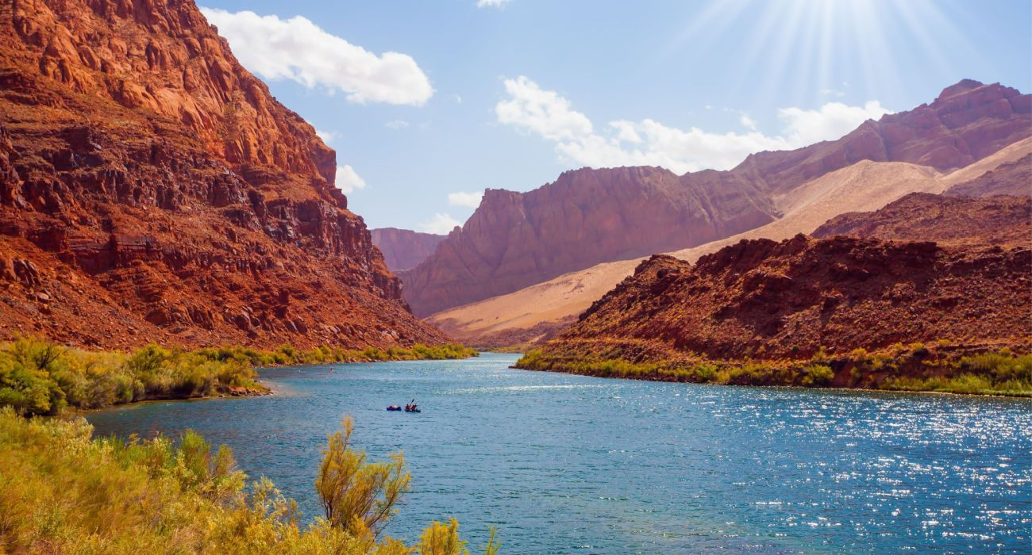
Veteran’s Day 2025 was the official deadline established by the US Bureau of Reclamation (BOR) for agreement in principle on new permanent guidelines for the operation of the Colorado River. The seven basin states involved have been negotiating for two years trying to come up with a replacement for the 2007 interim guidelines that expire at the end of next year (officially at the end of water year 2026 which began in October and extends through September). No deal has been made and national media have been quick to point out the “failure” of the negotiating process. However, the next deadline is Valentine’s Day 2026 when details of the agreement must be announced. The seven basin states have agreed to meet every Monday to reach an agreement by then.
Lee’s Ferry, Arizona

Water allocations to the seven basin states were first established in the Colorado River Compact signed in 1922. The Compact guaranteed water rights to the seven states with an equal allocation of 7.5 million acre-feet per year (MAFY) each to the upper basin (Colorado, Wyoming, Utah, and New Mexico) and lower basin (Arizona, Nevada, and California). An additional allocation of 1.5 MAFY was later made via a treaty with Mexico. MWD was formed in 1928 for the sole purpose of building the Colorado River Aqueduct to provide a reliable water supply for Southern California. The Aqueduct was completed in 1941 and began delivering water and hydroelectric power that year.

From 1941 until 2000, California was able to take as much water as it wanted because the other states did not yet need the water. Within California, MWD receives 12 percent of the state’s 4.4 MAFY allocation. The other 88 percent goes to irrigation districts in southeastern California. However, as the junior right-holder, MWD is granted all of the surplus water from the Colorado River when available.

In 2000, several things occurred that upset the traditional operation of the Colorado River. First, a major drought began that cut River flows substantially. Second, Nevada and Arizona water usage reached their respective maximum allocations and thus eliminated the surplus previously available to California and MWD. Third, because MWD was taking all of the surplus available to California, it was forced to reduce the amount of water taken from the Colorado River by 700,000 AFY to enable the state to stay within the 4.4 MAFY allocation.

In 2003, the lower basin states voluntarily and unilaterally agreed to cut 1.5 MAFY total from their allocation. That cut was divided among the states as follows: California 10 percent, Nevada 16 percent, and Arizona 28 percent. The lower basin further proposed that if cuts greater than 1.5 MAFY were needed in the future, the additional cuts would be equally divided among both the upper and lower basins. Unfortunately, the upper basin states rejected that proposal, arguing that because the lower basin states have used much more than the upper basin states, they should bear the brunt of the cuts. Needless to say, no agreement could be reached at that time.

The drought continued to worsen and caused an alarming drop in the elevation of Lake Mead (the lake formed by Hoover Dam and from which the lower basin states withdraw their share of the Colorado River water). Consequently, in 2007, the lower basin states agreed to interim guidelines for their operations (involving no action by the upper basin) that would result in cuts in deliveries to Arizona, Nevada, and Mexico but not California. The guidelines were structured to trigger those cuts based on the elevation of water in Lake Mead. The agreement was acceptable to the states other than California because California holds the senior right to water within the lower basin.

As is the case in California, most of the water from the Colorado River is used in other states by agriculture. Consequently, if significant further reductions in water use are to be achieved, agricultural users will have to do more. Federal funding for water conservation is available under the Infrastructure Act, however, much of that funding is being used for temporary conservation programs such as fallowing land. A more useful application of that money would be to construct permanent conservation facilities such as concrete lining of irrigation canals, and installation of sprinkler systems.

The elevation of water in Lake Mead has been relatively stable over the last few years and currently sits at 1055 feet. Dead pool occurs at 950 feet, below which no more water can be extracted and no power can be generated. The lowest elevation since the lake was filled occurred three years ago when it dropped to 1042 feet. MWD recently learned that a 70 percent reduction in power generation will occur below 1035 feet because the old turbines were not designed for use at that elevation and can no longer be used. Only four newer turbines were designed for low elevation operation. Such a loss in generation capacity would cause a significant cost to power utilities and their customers in Southern California.

After the seven basin states reach an agreement on permanent operational guidelines, the Bureau of Reclamation will negotiate a separate agreement with Mexico that will appropriately reduce the usage of water by the two affected states within Mexico. If the seven basin states cannot reach agreement, the BOR will impose its own guidelines on the seven states that may or may not include input of the users. MWD and California are concerned that such an imposition of rules may not be favorable to California and are thus focused on achieving a negotiated agreement by next summer.

